**Web Designing Assignment**

**Term-5**

**Module (JQuery Basic, Effects & Advanced) – 5**

1. **What is jQuery?**

**Ans**-jQuery is a fast and lightweight JavaScript library designed to simplify the client-side scripting of HTML. It was created by John Resig and released in 2006. jQuery makes it easier to manipulate HTML documents, handle events, create animations, and perform Ajax (Asynchronous JavaScript and XML) interactions.

**Key features of jQuery include:**

**1. DOM Manipulation:** jQuery simplifies the process of selecting and manipulating HTML elements in the Document Object Model (DOM). It provides a concise and consistent syntax for tasks like traversing and modifying the DOM.

**2.Event Handling:** jQuery allows easy attachment of event handlers to HTML elements. This simplifies the process of responding to user interactions such as clicks, keypresses, and mouse movements.

**3. Animations**: jQuery includes built-in methods for creating animations and effects, making it simple to add visual enhancements to web pages.

**4. Cross-browser Compatibility:** jQuery abstracts away many of the inconsistencies and quirks present in different web browsers, providing a more consistent and reliable development experience across various platforms.

**5. Plugins:** jQuery has a rich ecosystem of plugins that extend its functionality. These plugins cover a wide range of tasks, from advanced UI components to additional utilities for handling specific tasks.

1. **How to Apply CSS Using JQuery, How to Add Class and Remove Class in Jquery , JQuery Animation?**

**Ans**-

**Applying CSS using jQuery:**

You can apply CSS using jQuery by using the `css()` method. This method allows you to get or set one or more style properties for selected elements.

**Example: Applying CSS using jQuery**

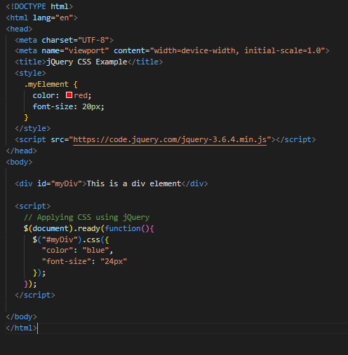

**Adding and Removing Classes using jQuery:**

You can use the `addClass()` and `removeClass()` methods to add and remove classes from elements.

Example: Adding and Removing Classes using jQuery

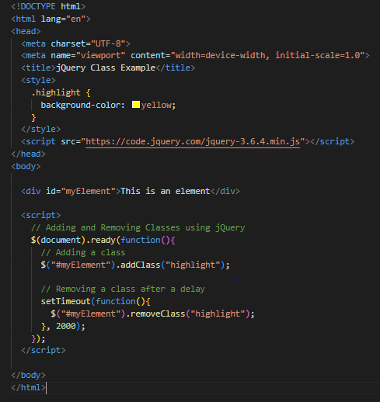

**jQuery Animation:**

jQuery provides various methods for creating animations. One common method is `animate()`, which allows you to animate CSS properties.

**Example: jQuery Animation**

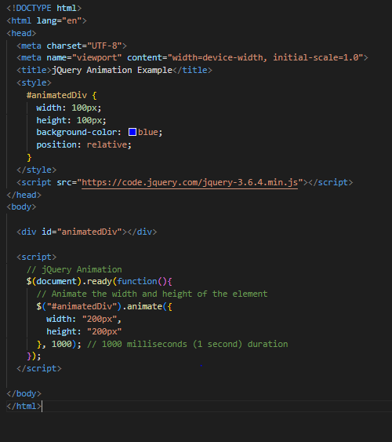

1. **How to create slider with animation?**

**Ans**-Creating a slider with animation involves using HTML, CSS, and JavaScript (including jQuery for simplicity). Below is a simple example of creating an image slider using jQuery for animation:

